Batch: A1 Roll No.: 16010123012

Experiment / Assignment / Tutorial No.: 07

Grade: AA / AB / BB / BC / CC / CD /DD

Signature of the Staff In-charge with date

Title: Implementation and configuration of Firewall using Iptable
______________________________________________________________________Objective: The objective of this experiment is to understand firewalls and configure iptables to control network traffic in a virtual machine.
______________________________________________________________________
Expected Outcome of Experiment:
Course Outcome | After successful completion of the course students should be able to
CO4 | Apply network security mechanisms for threat management
______________________________________________________________________
Abstract:
This experiment focuses on implementing and configuring a firewall using iptables in a Linux environment. A firewall acts as a security layer that monitors and controls network traffic based on predefined rules. In this experiment, various firewall policies are applied, such as allowing and blocking specific ports, filtering IP addresses, and managing incoming and outgoing connections. The setup is performed in a virtual machine to safely test configurations. The experiment helps in understanding practical network security mechanisms and traffic control techniques.
Related Theory:
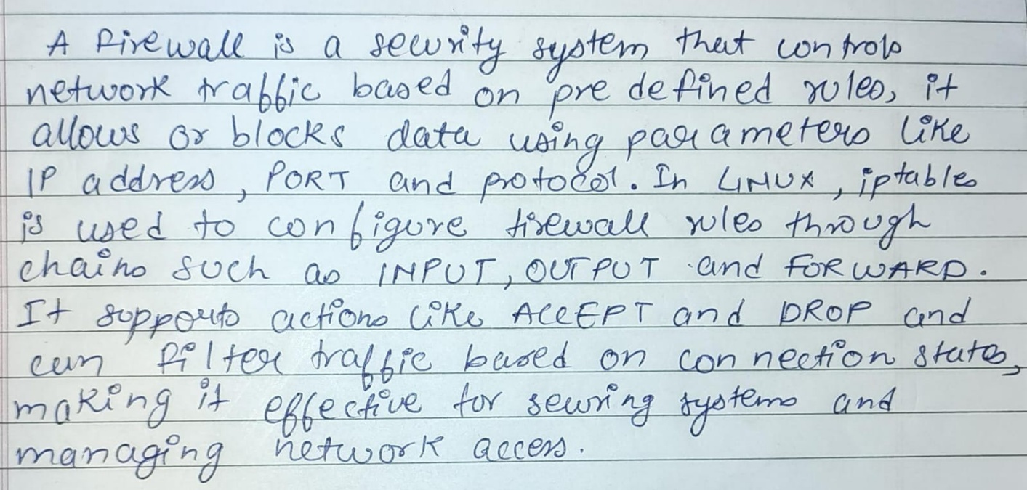
Implementation Details:
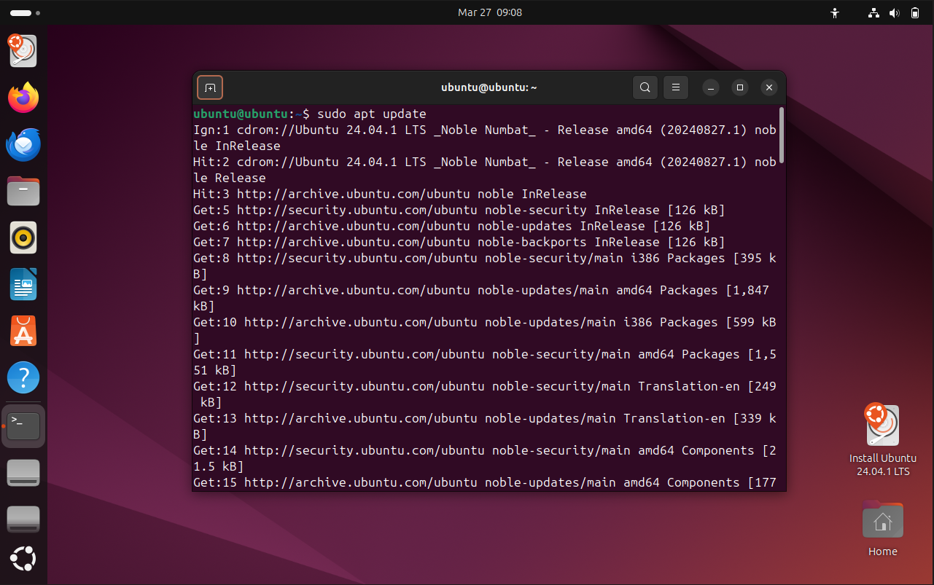
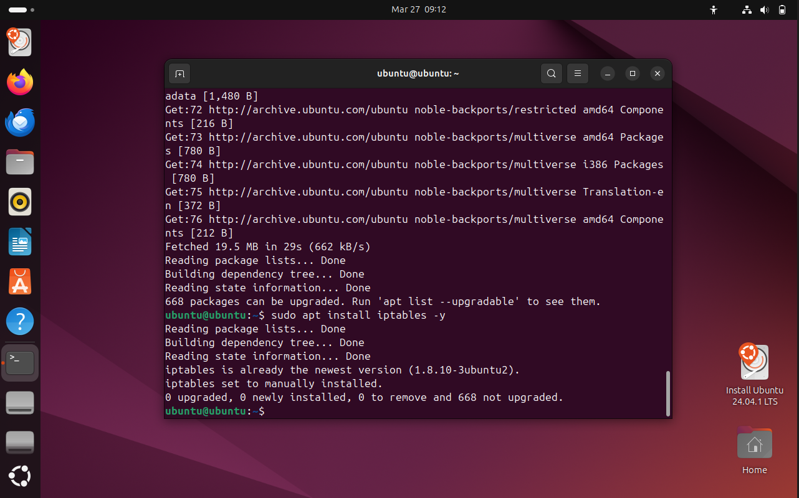
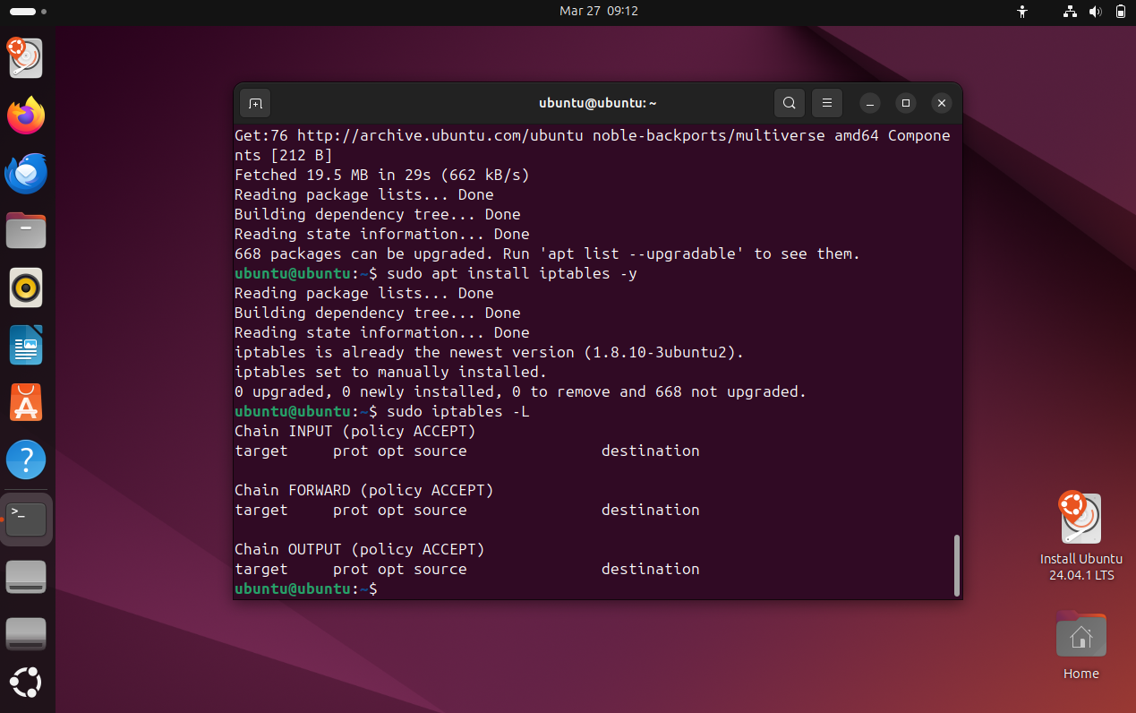
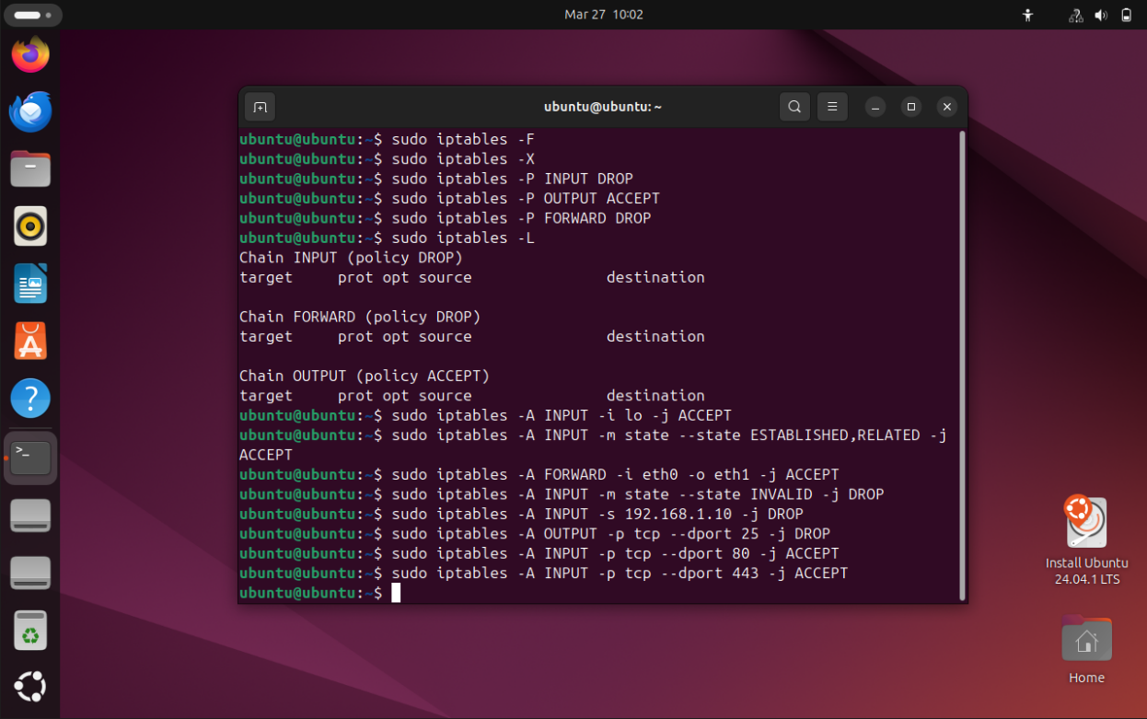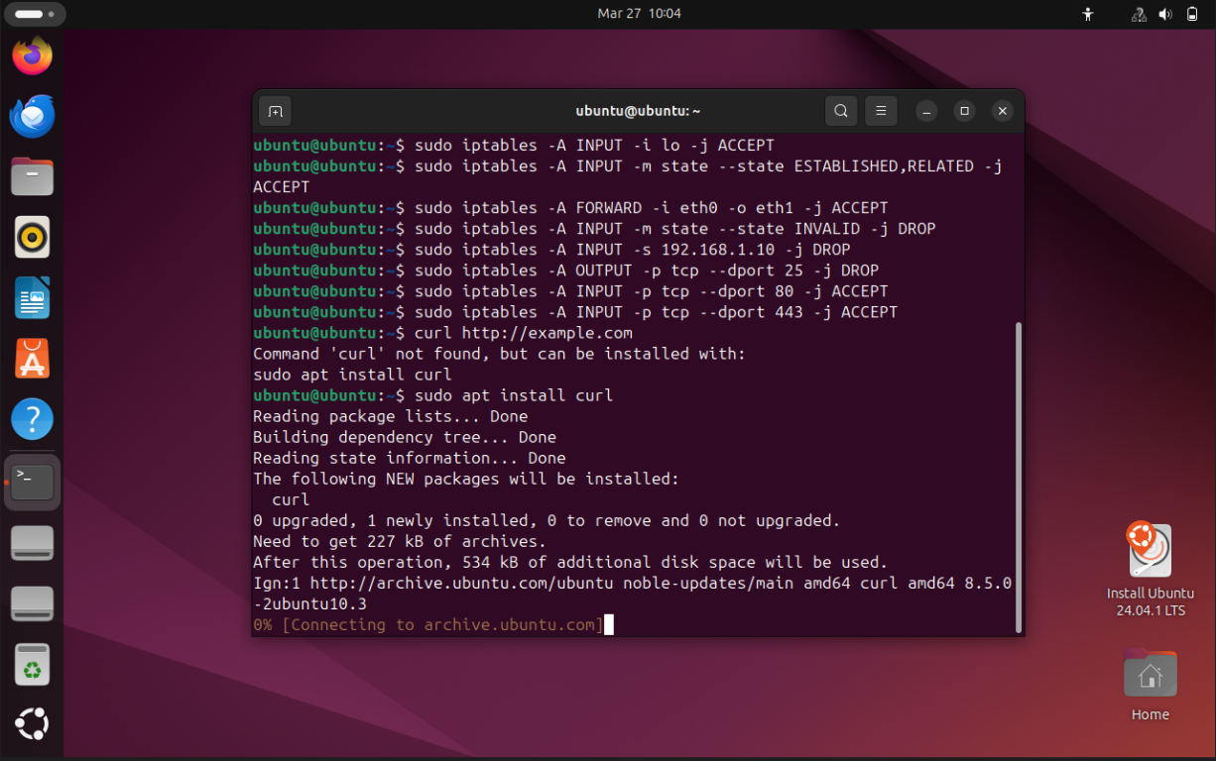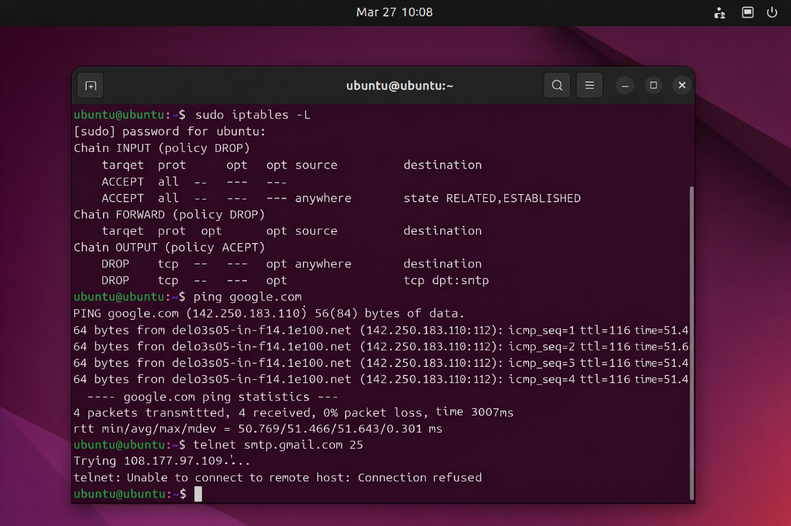

Conclusion:
In this experiment, a firewall was configured using iptables to control network traffic by allowing and blocking specific ports, IP addresses, and connections. The implementation demonstrated how firewalls monitor and filter traffic, reinforcing their role in protecting systems through rule-based network security.

